The American Certified Locator Program
Welcome to the American Certified Locator program. This website is for those seeking locator certification in the United States. To become a certified locator, you must pass an online exam covering four Parts:
Part A: Tickets and Maps
Part B: Utility Map Reading
Part C: Basic Utility Knowledge
Part D: Locating Instruments

The American Certified Locator Online Exam
The package cost of the four online exams is $125.00, or priced per Part at 50.00. The estimated time to complete Parts A-D is approximately 2 hours. A passing test score of 85% or higher is required to pass each Part, and if a candidate fails one or more of the Parts, they will fail the online locator certification exam.

Online Retesting

For candidates who have failed one or more exams, Part A-D online training courses are an option for retesting. The cost of each Part A-D training course is listed below. A candidate must score 85% on the Part A-D training course testing to pass the corresponding Part.

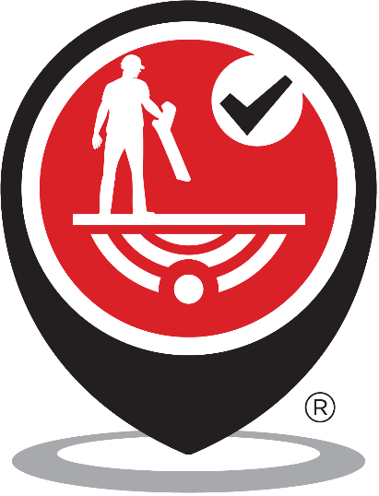
Costs of online training courses
Part A training course: Tickets and Maps $160.00
Part B training course: Utility Map Reading $240.00
Part C training course: Basic Utility Knowledge $460.00
Part D training course: Locating Instruments $680.00

3 or more persons from the same organization: 20% discount
10 or more persons from the same organization: 40% discount

Estimated minimum time commitment to complete training courses
Tickets and Maps: 2 hours
Utility Map Reading: 2 hours
Basic Utility Knowledge: 3 hours
Locating Instruments: 7 hours

Please contact Planet Underground to discuss video conference and face-to-face online exam retesting options. Also, contact Planet Underground to discuss options for scheduling a practical exam.

Email: info@planetunderground.tv or leave phone message at: 815-290-9808

The practical exam involves:
- Finding the correct location of the ticket/work order
- Determining the proper extent needed to be located
- Filling out a visual observation and utility map assessment
- 80% of the scoring is the ability to locate the extent accurately and completely
- A score of 85% is necessary to pass

Passing the practical exam completes the locator certification process. Certification is good for two years with continuing education satisfying the requirements for recertification.

